CIS 150 – Lab 1

Dr. Anys Bacha

Question 1:

- Start up visual studio.
- Choose file new project

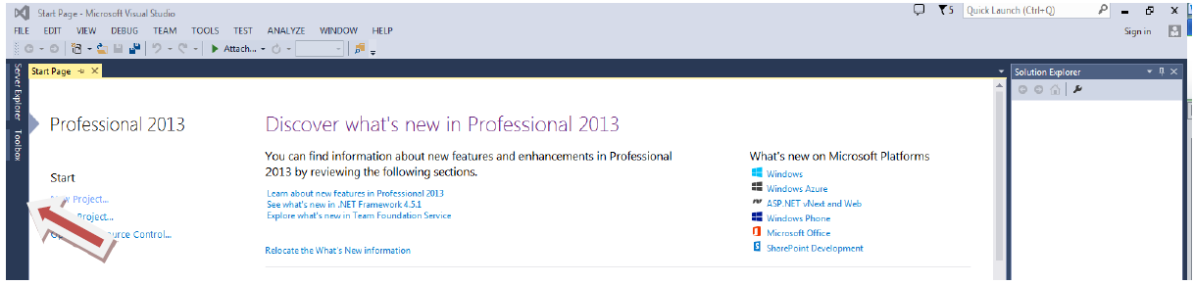

- Select Visual C++
- Choose Win32
- Choose Win32 Console Application
- Project add new item
- Choose a name

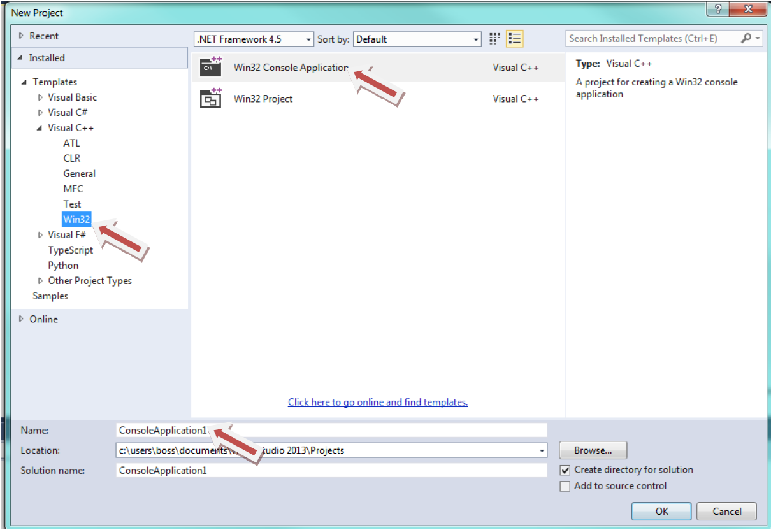

- Choose Application Settings hit the next button

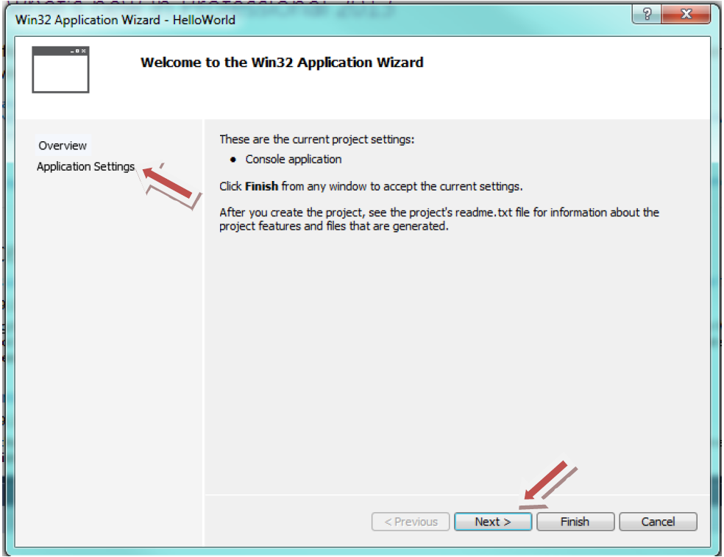

- Choose empty project and finish.

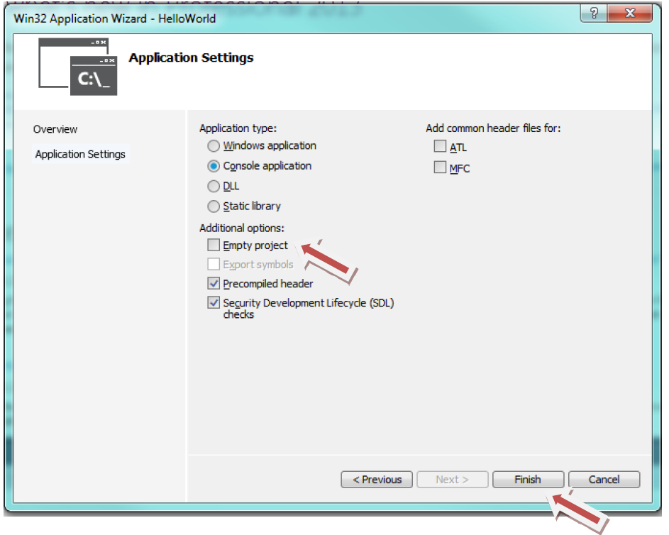

- Over the Source Files folder
- Right click and choose Add ➔ New Item

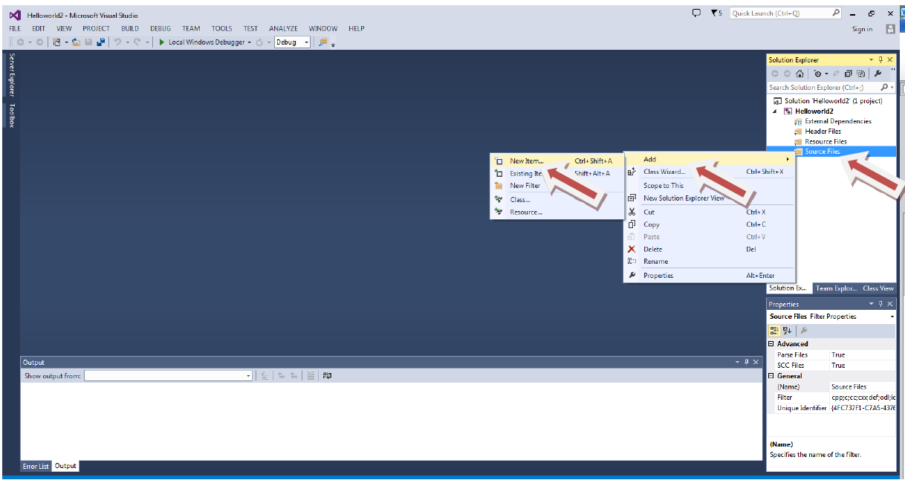

- Choose C++ File (.cpp)
- Give it a name and hit the add button

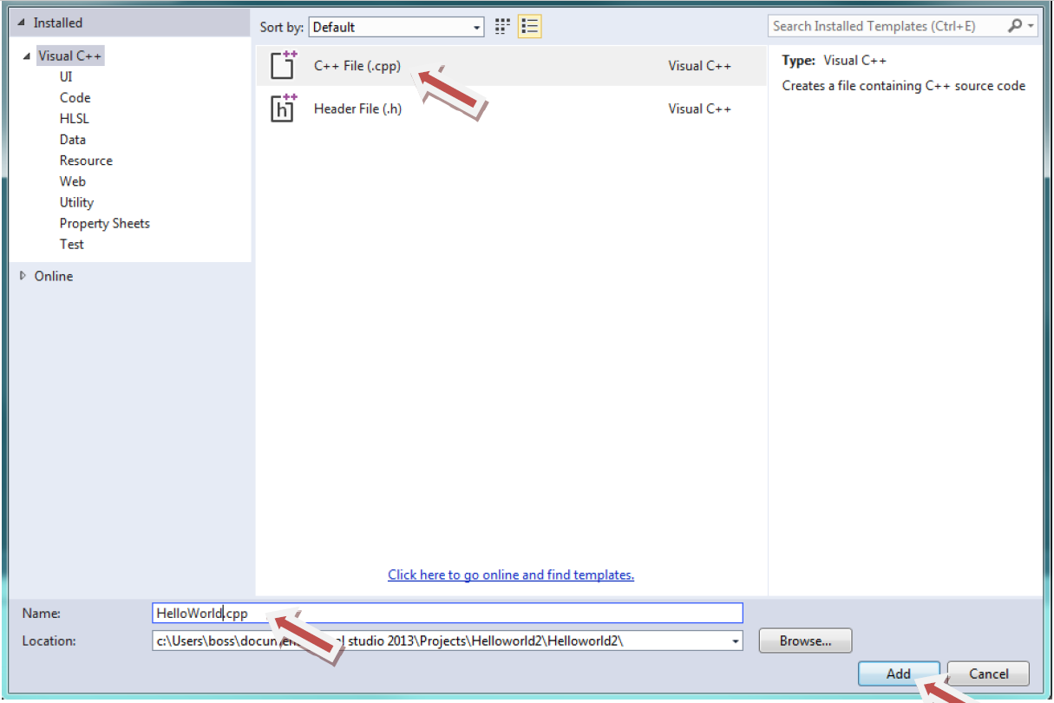

- Copy and paste the following code:
/*
*Author:
*Creation Date:
*Modification Date:
*Purpose:
*/
#include <iostream>

using namespace std;

int main()
{
cout << "Hello World!" << endl;
cout << "CIS 150 – Winter 2019" << endl;

system("pause");
return 0;
}

- To execute the application, on the Standard toolbar, click Debug -> Start without debugging
- After viewing the application, close it
- Provide a screen shot.

Question 2:

Run the following program. Make sure you provide the information in the header. Fix any bug in the program. Provide a screenshot of the execution.

/* Author:
Creation Date:
Last Modification Date:
Purpose:
*/

#include <iostream>
#indlude <string>
using namespace std;

int main() {

string first;

cout << endl << “Please enter your first name: “;
cin >> first;

cout << “Hi “ << first << “: I hope you will enjoy CIS 150 this semester.” << endl;

system(“pause”);
return 0;
}

Question 3:

Use the sample code given below to output this tree:

*
***
*****
*******

Sample code:
/* Author:
Creation Date:
Last Modification Date:
Purpose:
*/

#include <iostream>
using namespace std;

int main() {

/* Type your code here. */

system(“pause”);
return 0;
}

Submission of Your Work

You need to prepare ONE SINGLE MS word document that contains:

1. Report.
2. Be sure to have your NAME on it – Never forget the “header” of the program.
3. Paste in a copy of your source code for each question – Always specify the question.
4. Paste in a screen shot after each section of code (only the actual output)

Upload the file to Canvas (in the lab section) under the respective Lab assignment.

